Step 1: Go to PASS and click on Concur Travel Management icon.
If the employee is not already set up as a Concur user, the self-registration page will appear. Complete the required information and save.

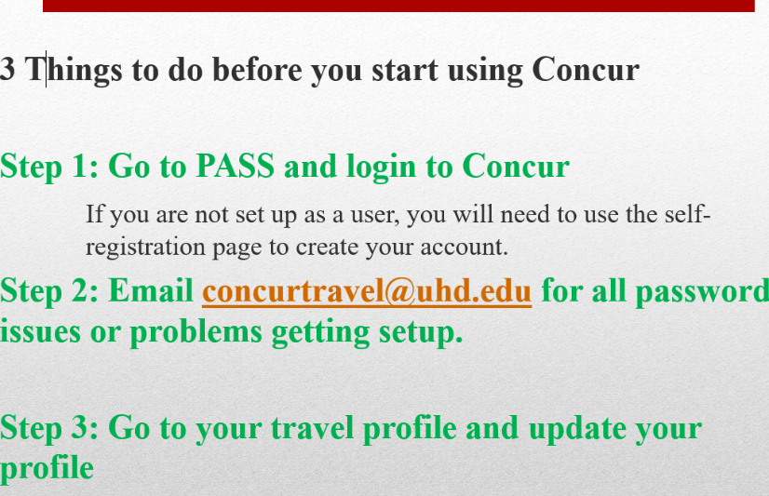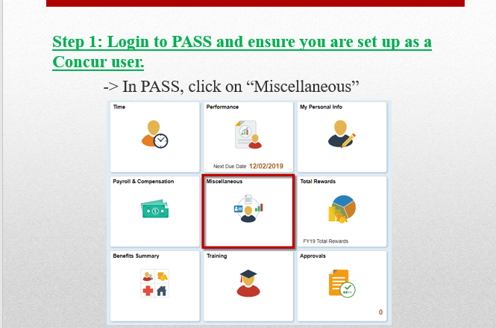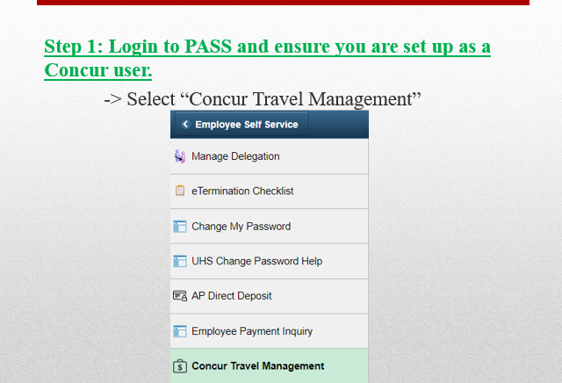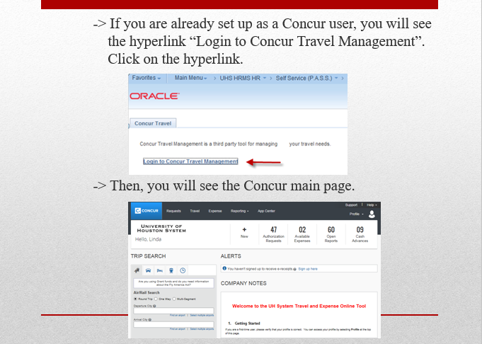

Step 2: Email concurtravel@uhd.edu if you are having password issues or if you are not setup as a Concur user in PASS, please make sure to have your department cost center information available before you proceed.

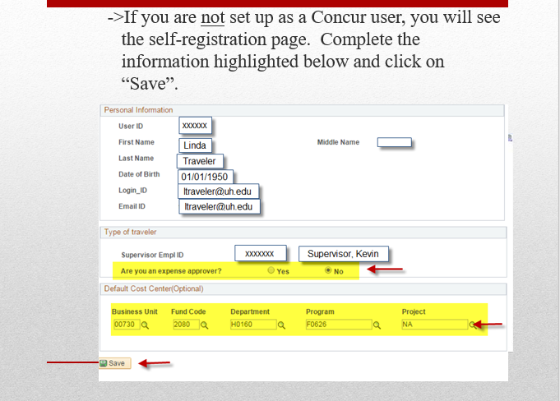

Step 3: Follow the instructions in the attachment titled, Getting Started in Concur- UHD **Note**Concur verifies it’s users by email and phone numbers, please make sure to input the correct email addresses and phones numbers should be consecutive without any special characters, example (7132218608)

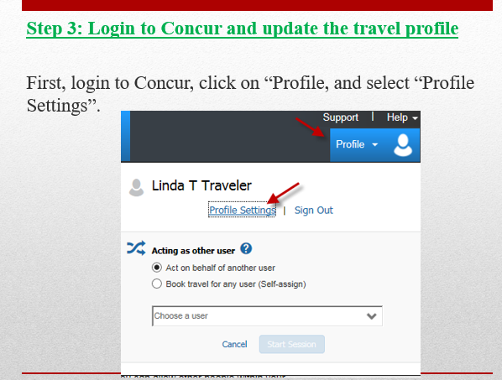

Please try to use Edge if Chrome does not work.

